State of Vermont Agency of Human Services
Assistive Technology Program
HC 2 South, 280 State Drive [toll free] 800-750-6355
Waterbury, VT 05671-1090 [phone] 802-241-0285
www.atp.vt.gov [fax] 802-871-0341

Dear Vermont Special Education Administrators:

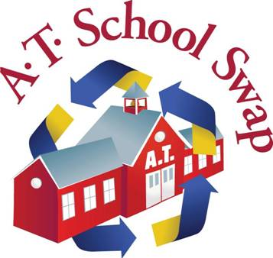

www.vermont.atschoolswap.com

Greetings from the VT Assistive Technology School Swap* for the 2016 school year! AT School Swap (www.vermont.atschoolswap.com) provides schools with an opportunity to find free or low-cost Assistive Technology and Durable Medical Equipment (DME) for their students. Past exchanges have included: AAC devices, Tumble Form Standers, Rifton Activity Chairs, adapted keyboards, and many other types of assistive technology.

Per formal agreement with the Federal Department of Education and the Vermont Agency of Education, all schools in Vermont can use the AT School Swap to share equipment with any supervisory union in the state.
ol

To enroll, please have your Special Education Director sign and scan the attached enrollment form to emma.cobb@vermont.gov. If you have a staff person who would like to join later in the year we can accommodate that as well. You may also access the form on our website www.atp.vt.gov - click on VT AT Reuse Project.

Vermont also has a community-based exchange for Assistive Technology and DME at www.getatstuff.com This is an additional resource where schools can obtain, but not sell or give away equipment. Again please note, schools can only post available equipment on AT School Swap, per agreement with the U.S. Department of Education.

Please contact me for registration information and with any questions.

I look forward to answering any questions you might have and to help you get started as a member of the VT AT School Swap!

Thank you,

Emma Cobb, AT Services Coordinator
VT Assistive Technology Program
1-800-750-6355
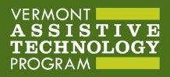

Atts.

*AT School Swap is a project of the Vermont Assistive Technology Program and is both federally and state endorsed. Funding for the Vermont Assistive Technology program is through the U.S. Department of Health and Human Services; Administration for Community Living.

